NAME-AAKANKSHA BARTHWAL

COURSE – MCA

SECTION- B

ROLL NO-2001001

QUESTION 1:

print(10+5)

print(10*5)

print(10/2)

print(10%2)

print(10**2)

print(10//2)

OUTPUT 1:

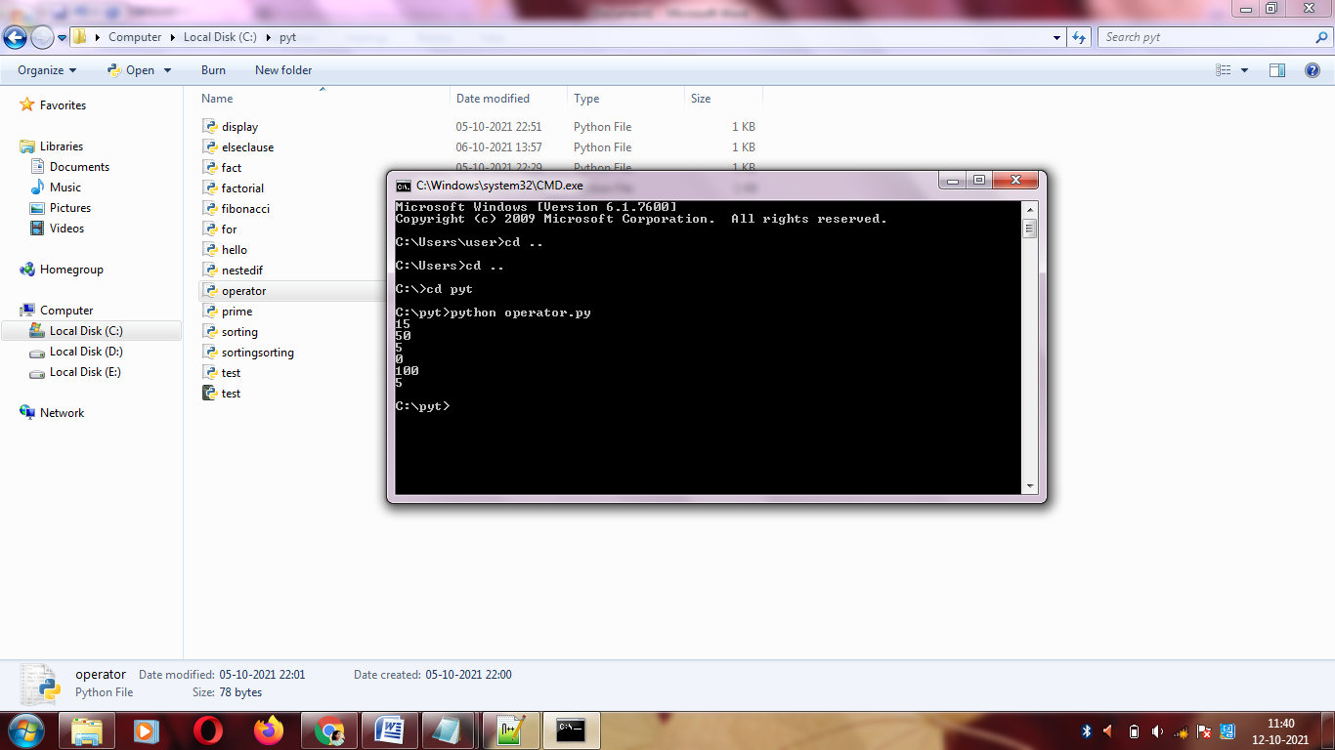

QUESTION 2:

def fib(n):

a = 0

b = 1

if n == 1:

print(a)

else:

print(a)

print(b)

for i in range(2,n):

c = a + b

a = b

b = c

print(c)

fib(10)

OUTPUT 2:

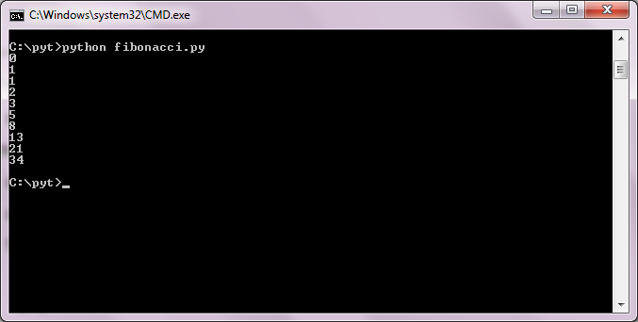

QUESTION 3:

num = int(input("Enter a number: "))

factorial = 1

if num < 0:

print(" Factorial does not exist for negative numbers")

elif num == 0:

print("The factorial of 0 is 1")

else:

for i in range(1,num + 1):

factorial = factorial*i

print("The factorial of",num,"is",factorial)

OUTPUT 3:

num = int(input("Enter a number: "))

factorial = 1

if num < 0:

print(" Factorial does not exist for negative numbers")

elif num == 0:

print("The factorial of 0 is 1")

else:

for i in range(1,num + 1):

factorial = factorial*i

print("The factorial of",num,"is",factorial)

OUTPUT 4:

number = int(input("Enter The Number"))

if number > 1:

for i in range(2,int(number/2)+1):

if (number % i == 0):

print(number, "is not a Prime Number")

break

else:

print(number,"is a Prime number")

OUTPUT 4:

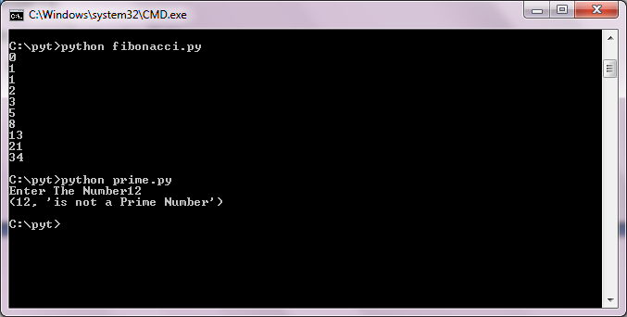

QUESTION 5:

def display_message():

return "Welcome to Graphic Era!"/

import test

print(test.display_message())

OUTPUT 5:

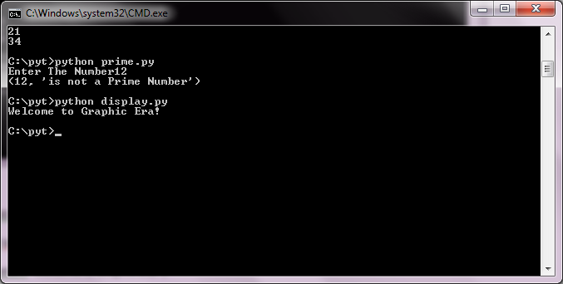

QUESTION 6:

var = 100

if var < 200:

print "Expression value is less than 200"

if var == 150:

print "Which is 150"

elif var == 100:

print "Which is 100"

elif var == 50:

print "Which is 50"

elif var < 50:

print "Expression value is less than 50"

else:

print "Could not find true expression"

print "bye bye!"

OUTPUT:

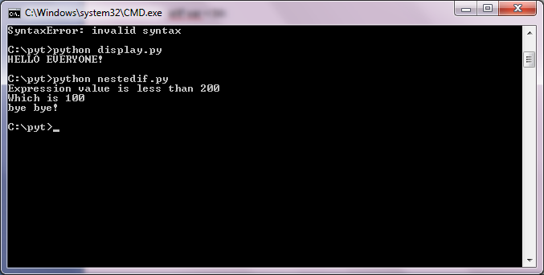

QUESTION 7:

var1 = 0

if var1:

print "1 - Got a true value"

print var1

else:

print "1 - Got a false value"

print var1

var2 = 50

if var2:

print "2 - Got a true value"

print var2

else:

print "2 - Got a false value"

print var2

print "Good bye!"

OUTPUT:

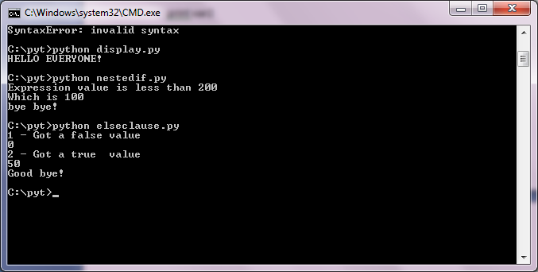

QUESTION 8:

L1=["apple","mango","banana","kiwi"]

L2=["Rose","Lily","Sunflower"]

# appending new elements to the list

L1.append(L2)

print(L1)

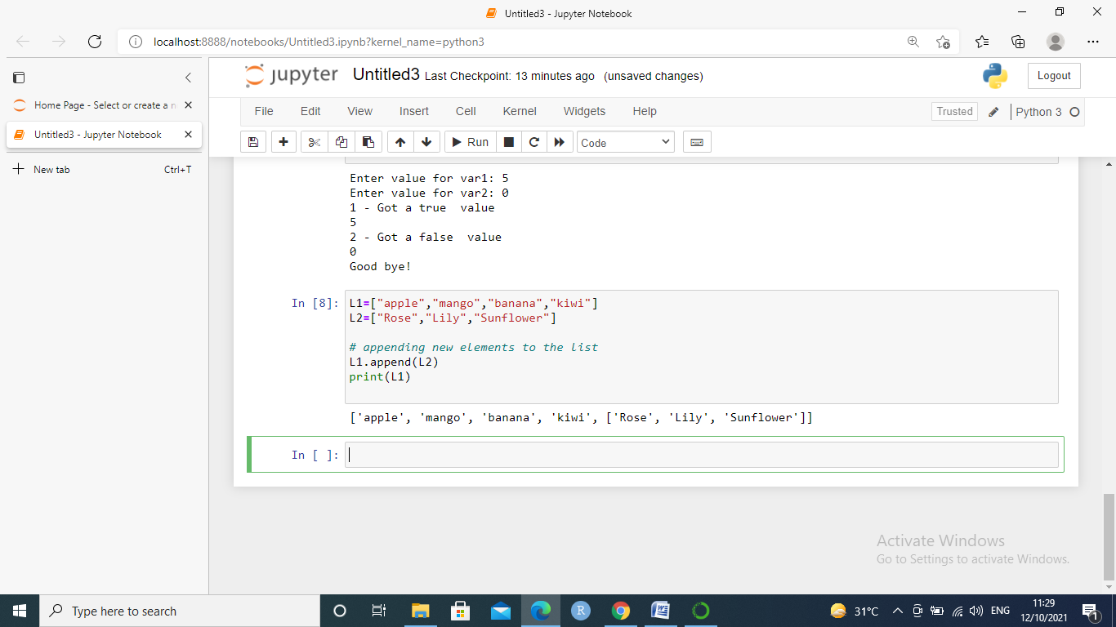

QUESTION 9:

def search(Li, x):

for i in range(len(Li)):

if Li[i] == x:

return i

return -1

Li=[12,87,34 ,95,67 ,78,39,25,45,56,48,66,99,100]

num = int(input("Enter the number you want to search: "))

result = search(Li,num)

if (result==1):

print(num ,"is at ", result,"th index")

else:

print("The element you want to search is not present in the list.")

print(" ")

print("List before soting: ")

print(Li)

Li.sort()

print("List after sorting: ")

print(Li)

OUTPUT:

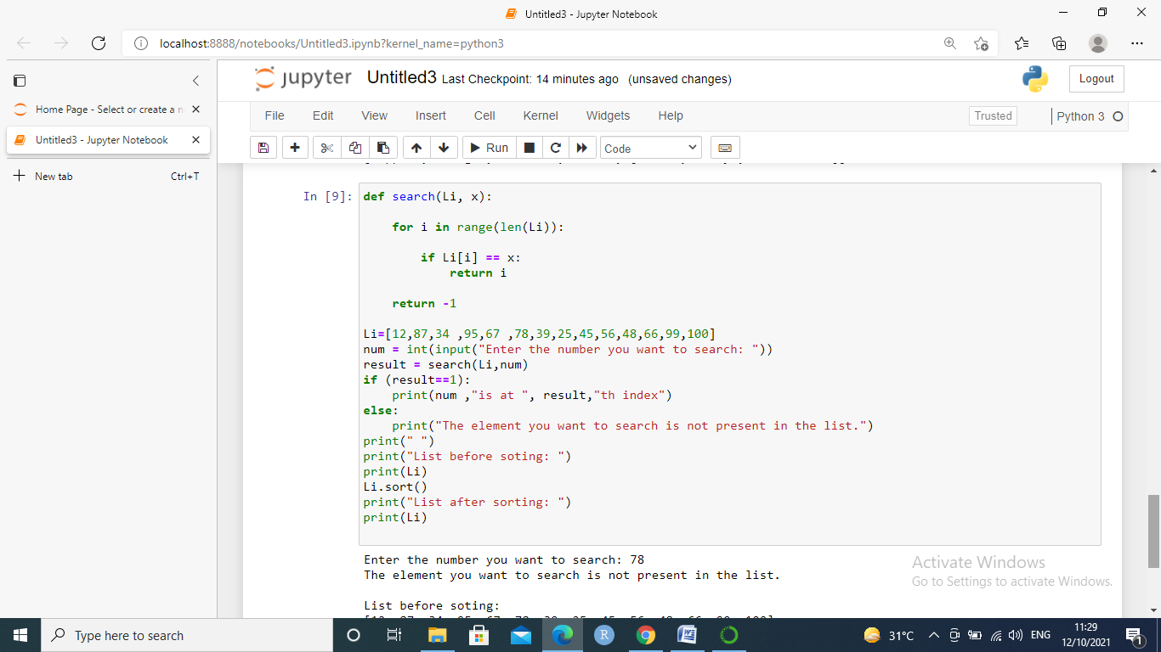

QUESTION 9:

def search(Li, x):

for i in range(len(Li)):

if Li[i] == x:

return i

return -1

Li=[12,87,34 ,95,67 ,78,39,25,45,56,48,66,99,100]

num = int(input("Enter the number you want to search: "))

result = search(Li,num)

if (result==1):

print(num ,"is at ", result,"th index")

else:

print("The element you want to search is not present in the list.")

print(" ")

print("List before soting: ")

print(Li)

Li.sort()

print("List after sorting: ")

print(Li)

OUTPUT9:



QUESTION 10:

dict={}

dict={1:'Monday',2:'Tuesday',3:'Wednesday',4:'Thursday',5:'Friday',6:'Saturday',7:'Sunday'}

print("Type",type(dict))

print(dict)

print(dict[1])

res=dict.get("2")

print(res)

OUTPUT :

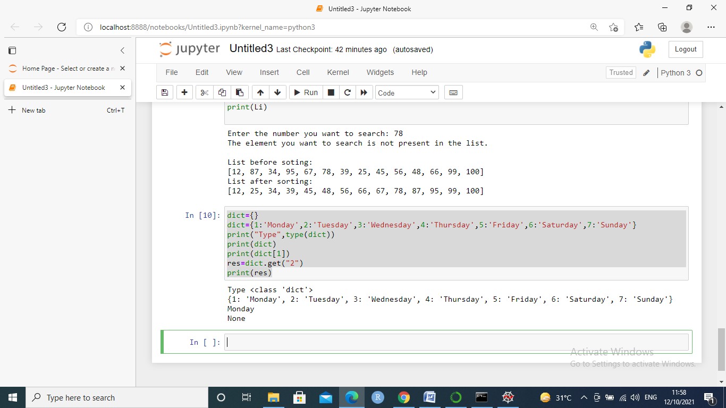

1. Programs on Statistical Concepts and introduction to Linear Algebra using Python

1.Write a program to find the mean. mode and median of the given range of numbers.

#ques1

sum=0

x=[2,3,4,6,2,4,5,6,7,8]

#mean

for i in x:

sum=sum+i

mean=sum/len(x)

print(mean)

#median

n=len(x)

x.sort()

if(n%2==0):

med1=n//2

med2=(n//2)+1

final_median=(x[med1-1]+x[med2-1])/2

else:

final_median=x[n//2]

print(final_median)

#mode

import statistics

mode2=statistics.mode(x)

print(mode2)

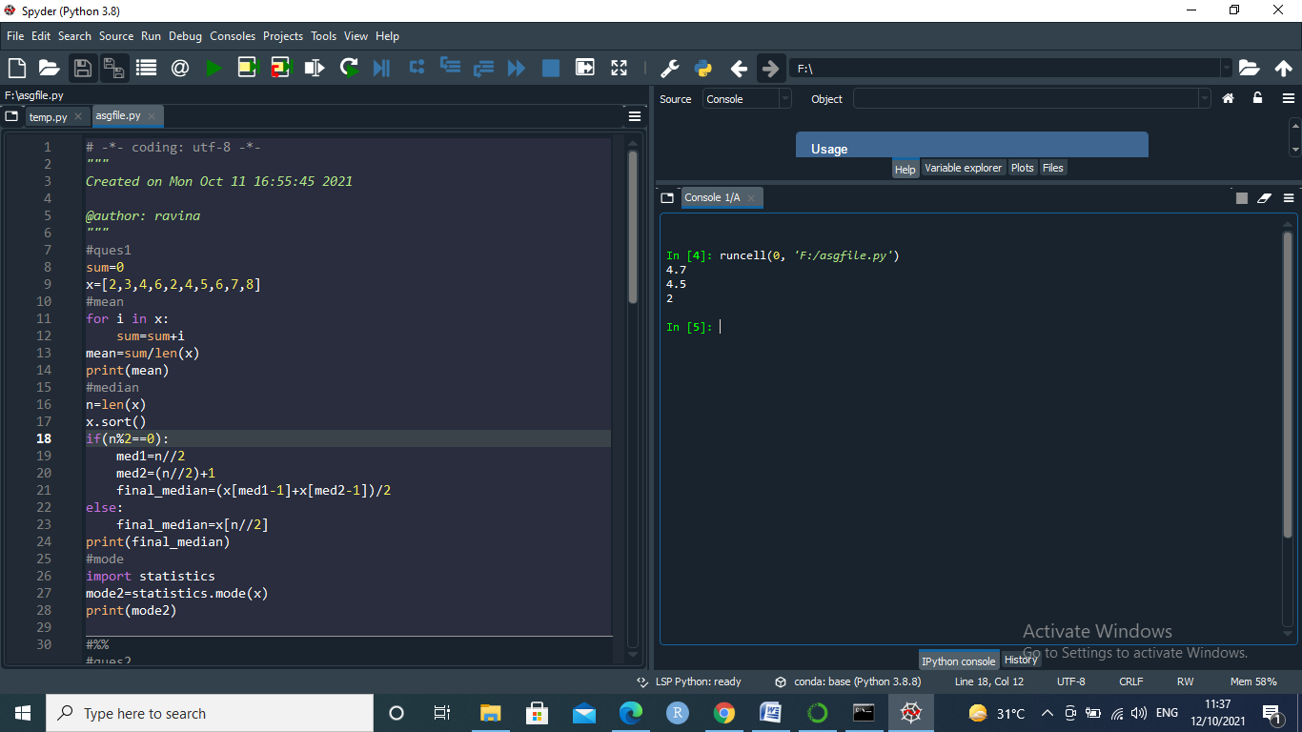

2 Write a program to calculate the standard deviation of a given set of numbers.

observation = [1,5,4,2,0]

sum=0

for i in range(len(observation)):

sum+=observation[i]

mean= sum/len(observation)

sum_of_squared_deviation = 0

for i in range(len(observation)):

sum_of_squared_deviation+=(observation[i]- mean)**2

sd = ((sum_of_squared_deviation)/len(observation))**0.5

print("Standard Deviation of sample is ",sd)

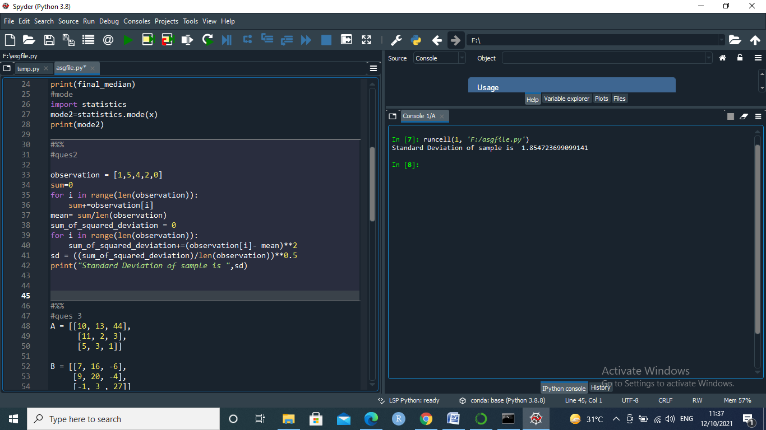

1. Write a program to calculate the addition of two 3x 3 matrices.

#ques 3

A = [[10, 13, 44],

[11, 2, 3],

[5, 3, 1]]

B = [[7, 16, -6],

[9, 20, -4],

[-1, 3 , 27]]

C = [[0,0,0],

[0,0,0],

[0,0,0]]

matrix_length = len(A)

#To Add mat1 and mat2 matrices

for i in range(len(A)):

for k in range(len(B)):

C[i][k] = A[i][k] + B[i][k]

#To Print the matrix

print("The sum of Matrix mat1 and mat2 = ", C)

for i in C:

print (i)

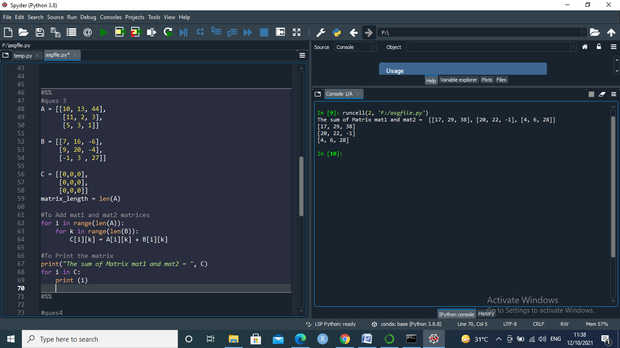

1. Write a program to calculate the multiplication of two 3x 3 matrices.

#ques4

# 3x3 matrix

X = [[12,7,3],

[4 ,5,6],

[7 ,8,9]]

# 3x4 matrix

Y = [[5,8,1,2],

[6,7,3,0],

[4,5,9,1]]

# result is 3x4

result = [[0,0,0,0],

[0,0,0,0],

[0,0,0,0]]

# iterate through rows of X

for i in range(len(X)):

# iterate through columns of Y

for j in range(len(Y[0])):

# iterate through rows of Y

for k in range(len(Y)):

result[i][j] += X[i][k] * Y[k][j]

for r in result:

print(r)

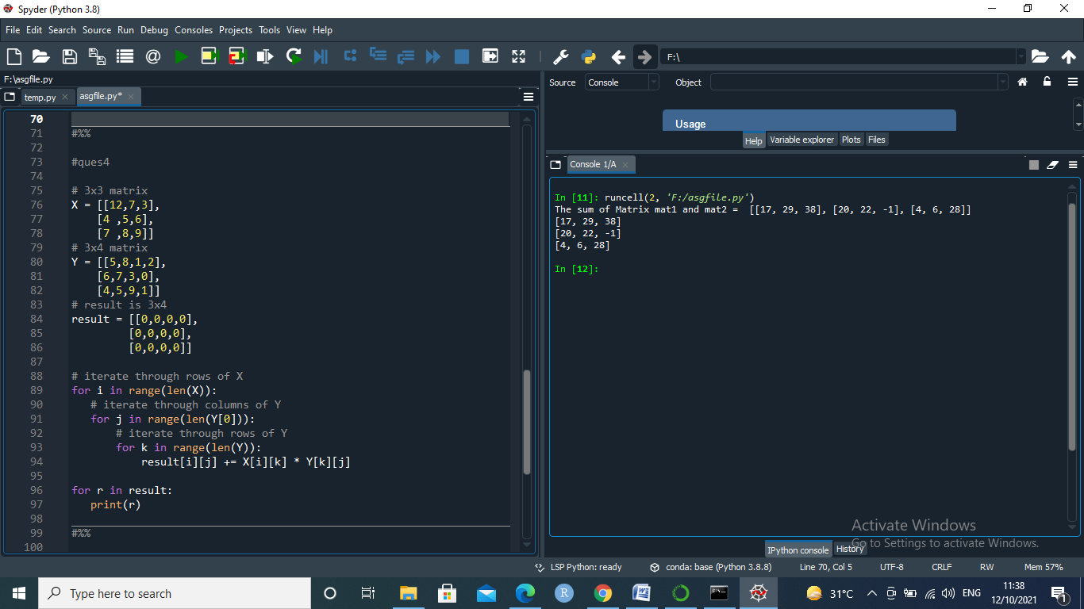

1. Write a program to calculate the inverse of the given matrix.

# ques 5

# Transpose of Matrix

# 3x3 matrix

X = [[12,7,3],

[4 ,5,6],

[7 ,8,9]]

Transpose = [[0,0,0],

[0,0,0],

[0,0,0]]

for i in range(len(A)):

for k in range(len(B)):

Transpose[i][k] = X[k][i]

for t in Transpose:

print(t)

